Implementation and testing:-

1. Add functional area and project name to idea email

This should be included in every email the Functional

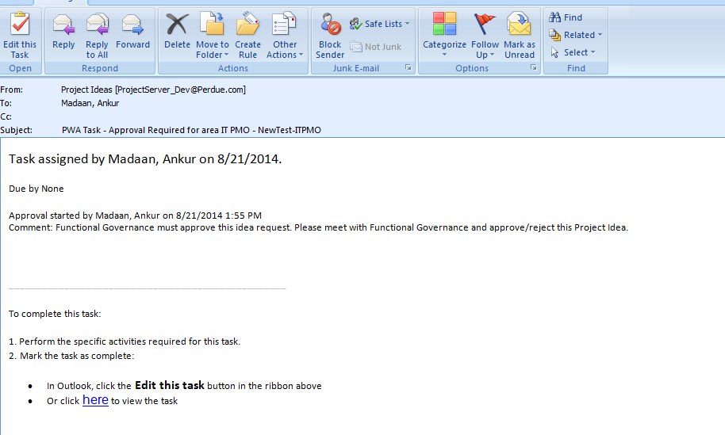

1. Additional Email Added, (Was not included in initial Scope)

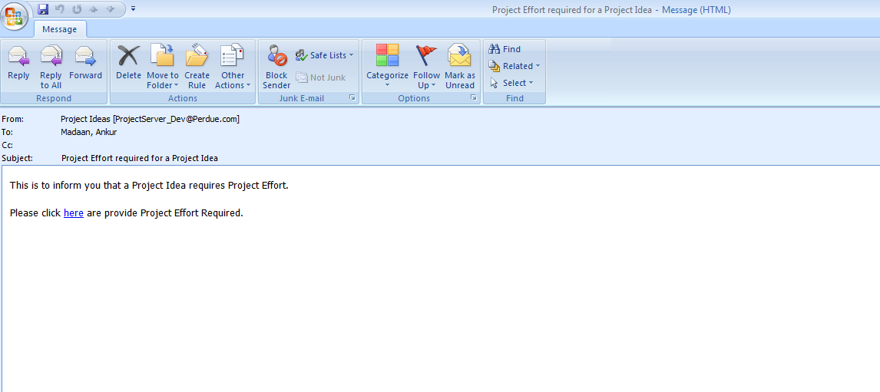

Change it as per Donna’s Updates.

1. Automate Small project task creation. (will need workflow source code for this)

If a project idea is approved and the hours are less than or equal to 80 – then the project manager’s **functional area** ‘for this project idea’ should create a new task in the current FY small project bucket for that functional area.

Determining calculation for FY –

If the date the workflow is executed <= last Sunday of the month of March

the fiscal year = the current calendar year,

if the date is AFTER the last Sunday of the month of march

the fiscal year = the current calendar year + 1

assumptions - PMO needs to make sure the PMO small projects have names that match the functional area name in idea and follows this standard naming convention FYnn – xxxx (where xxxx=functional area name)

* Negative testing

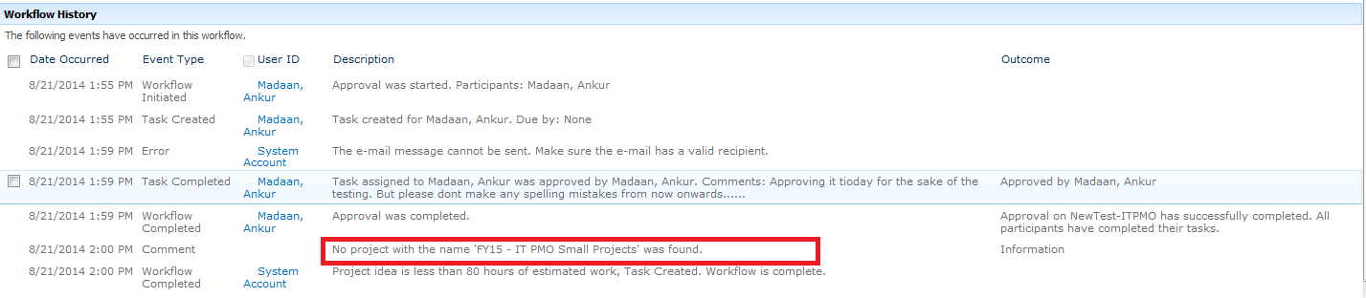

Need to Email PMO Admin if in case IT PMO Small Projects is not present already.

* Positive testing

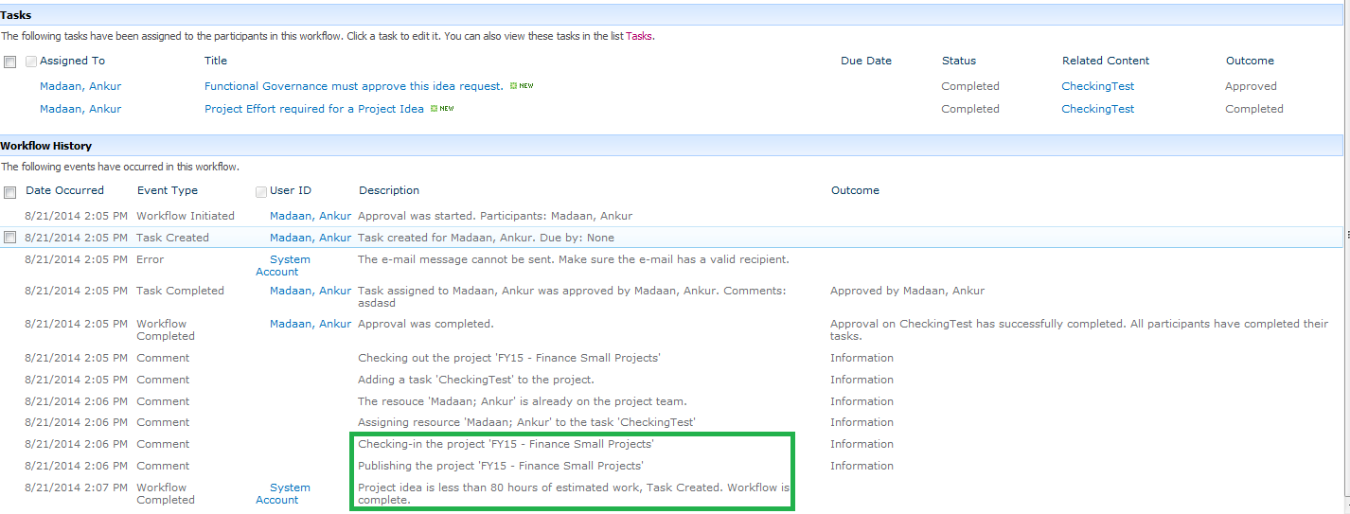

1. Add link to idea in cc email

Note: you click here to to view the task and make updates – but would be nice to be able to review the idea in total before going here.

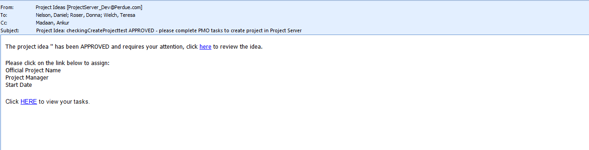

1. Non IT gated Project Creation lesser than 480 hours.

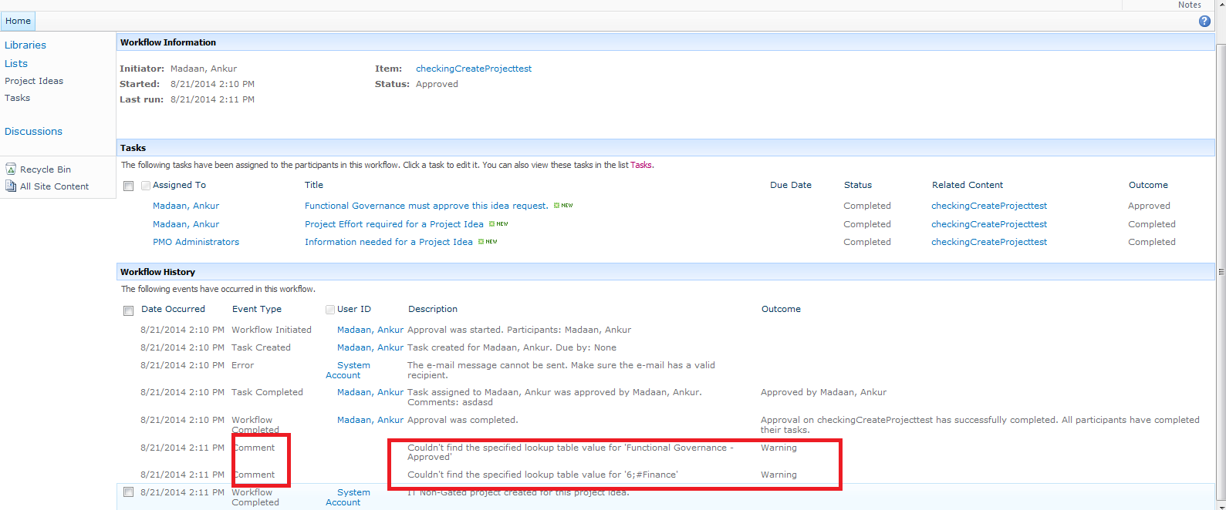

1. Gated project Creation more than or equals 480 hours.

